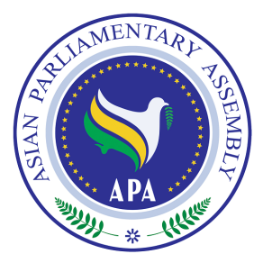

Draft Resolution
Submitted by the Executive Council on the Streamlining of the APA Work

We, the Members of the Asian Parliamentary Assembly,
Determined to promote the objectives and principles of the APA Charter,
Aware of the importance of a thorough deliberation of the issues under consideration at different meetings of the APA,
Stressing our resolve to participate and contribute actively in the deliberation of issues under consideration in APA meetings,
Affirming that streamlining the organization of the APA will improve the overall efficiency of APA activities,
Affirming also the need for Member Parliaments to provide inputs, on regular basis, about ways to promote implementation of APA resolutions and decisions, therefore recommend Member Parliaments to appoint special assistant(s) to provide advice to the delegates,
- Welcome the Report of the Secretary-General on Streamlining the Organization of the Sub-Committee Meetings contained in document, SG/Rep/2009/12;
- Urge APA Troika plus two other APA leaders covering all geographical sub-regions of Asia to continue to make representation, on behalf of the APA, in areas and situations of conflict in order to help defuse the situation and promote international peace and security, and request the Secretary-General to develop a framework for the activities of Troika+2;
- Decide to reduce the number of APA Standing Committees to three under the general titles of Standing committee on Political Affairs, Standing Committee on Social and Cultural Affairs and Standing Committee on Economic Affairs; each to be chaired by one of the Vice-Presidents of the APA plenary for a period of two years; the fourth Vice-President will oversee the financial and budget regulations of the APA and their implementations;
- Decide to hold the Sub-Committee meetings under the three Standing Committees during March, May and July of each year; the May meeting shall be held at the APA Headquarters;
- Decide also to identify the host parliament for March and July meetings when adopting the resolution at the plenary, and recognizing that the host parliament chairs the meeting of the sub-committee;
- Request the Secretary-General to implement this resolution and to forward, within 45 days after the closure of each Plenary, to all APA Member parliaments a calendar of APA inter-sessional meetings of the Sub-Committees. The calendar of APA inter-sessional meetings should list the group of Sub-Committees under a Standing Committee that will meet in each of the three inter-sessional meetings in March, May and July of each year;
- Further request the Secretary-General to conduct consultations, within the period of 45 days referred to above, with Member Parliaments to identify Member Parliaments interested in hosting and those interested in participating in any of the Sub-Committee meetings at a time different than the three inter-sessional meetings in March, May and July.

